**Islamabad:**

Margalla Hills

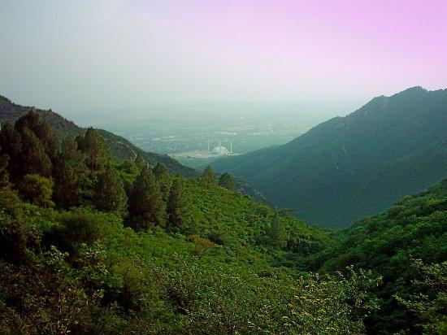

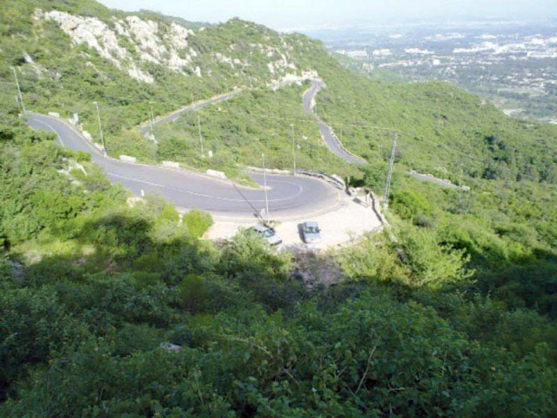

The **Margalla Hills** is a hill range which is part of the Himalayan foothills located within the Margalla Hills National Park, north of Islamabad, Pakistan. The Margalla range has an area of 12,605 hectares. The hills are a part of Murree hills. It is a range with many valleys as well as high mountains.